 | 26.14.10 Editors - Properties Editor - Object Data Properties Tab - Lattice Object
Table of content
Detailed table of content 1
Lattice panel 4
Workflow 4
Resolution U / V / W 4
Interpolation U / V / W 4
Outside 4
Vertex Group 4
Vertex groups panel 5
Active Vertex Group list 5
Add + 5
Remove - 5
Specials menu 6
Shape Keys panel 7
Workflow 8
Active Shape Key Index 9
Add + 9
Remove - 9
Specials Menu 10
Relative 11
Custom Properties Panel 12
Add 12
Edit 13
Remove 13

Detailed table of content
Detailed table of content
Detailed table of content 1
Lattice panel 4
Workflow 4
Resolution U / V / W 4
Interpolation U / V / W 4
Outside 4
Vertex Group 4
Vertex groups panel 5
Active Vertex Group list 5
Group name 5
Lock 5
Drag Handler 5
Search Field 5
Invert 5
Sort by Name 5
Add + 5
Remove - 5
Specials menu 6
Sort by Name 6
Sort by Bone Hierarchy 6
Duplicate Vertex Group 6
Copy Vertex Group to Selected 6
Mirror Vertex Group 6
Mirror Vertex Group (Topology) 6
Remove from All Groups 6
Clear Active Group 6
Delete All Unlocked Groups 6
Delete All Groups 6
Lock All 7
Unlock All 7
Lock Invert All 7
Move Vertex Group Up / Down 7
Assign 7
Remove 7
Select 7
Deselect 7
Weight 7
Auto Normalize 7
Shape Keys panel 7
Workflow 8
Active Shape Key Index 9
Shape Key name 9
Slider value 9
Lock 9
Drag Handler 9
Search Field 9
Invert 9
Sort by Name 9
Add + 9
Remove - 9
Specials Menu 10
New Combined 10
Duplicate 10
Copy from Objects 10
Mirror Shape Key 10
Mirror Shape Key (Topology) 10
New from Objects 10
New from Objects Flipped 10
Update from Objects 10
Update from Objects 10
Transfer Shape Key 10
Apply all Shape Keys 10
Delete all Shape Keys 10
Lock All 11
Unlock All 11
Make Basis 11
Move to Bottom 11
Move Shape Key Up / Down 11
Relative 11
Relative 11
Shape Key Lock (pin icon) 11
Shape Key Edit Mode (edit mode icon) 11
Value 11
Range 11
Vertex Group 11
Relative To 12
Absolute 12
Shape Key Lock (pin icon) 12
Shape Key Edit Mode (edit mode icon) 12
Re-Time Shape Keys (clock icon) 12
Interpolation 12
Evaluation Time 12
Custom Properties Panel 12
Add 12
Edit 13
Remove 13

Lattice panel
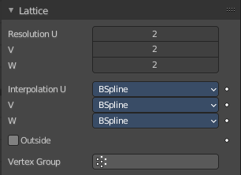
Lattice objects can be used to deform child geometry by the cage of the lattice object.

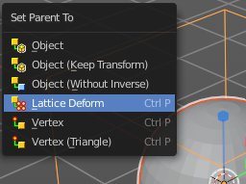
Workflow
Create a lattice. Create a mesh object like a sphere.
Parent this sphere at the lattice. With method Lattice deform.

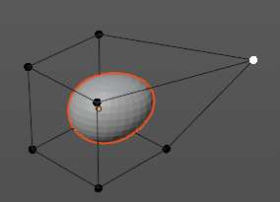
Select the lattice object and enter Edit mode.
Pull the vertices of the lattice cage. And the child geometry will deform.

Resolution U / V / W
The subdivision resolution of the Lattice object. A resolution of 1 makes the lattice one dimensional.

Interpolation U / V / W
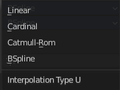
The interpolation selector for each axis. How the Lattice cage influences the child geometry. Each method gives a slightly different result.

Outside
Takes only the vertices on the surface of the lattice into account.

Vertex Group
Apply the influence of the lattice to a vertex group instead of a whole mesh

Vertex groups panel
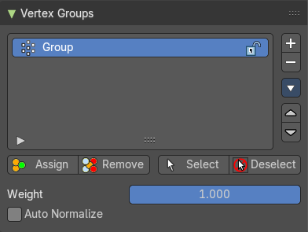
A Vertex group is a group of vertices, a selection of the mesh. It is for example used to weight a specific mesh part to a bone. Or to control the growth of hair particles.
This panel allows you to manage and edit vertex groups. Weight painting creates vertex groups automatically.
In Edit mode this panel shows some further controls.
Vertex groups exists for mesh and lattice objects.

Active Vertex Group list
A List of the vertex groups for this mesh.

Group name
The name of the group. It can be renamed by double clicking at it.

Lock
The lock icon at the end of a group name locks the group from being editable.

Drag Handler
The two vertical lines at the end is a handler with which you can expand the list.

Search Field

You can expand a search field at the bottom of the list. Type in your term and hit enter to filter for your term.

Invert
Exclude the search term instead of searching for it.

Sort by Name
Sort the List by name.

Add +
Create an empty vertex group.

Remove -
Deletes the active vertex group.

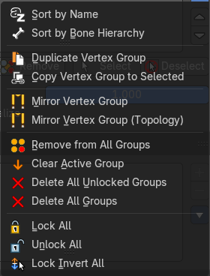
Specials menu

Sort by Name
Sorts the vertex groups alphabetically by name.

Sort by Bone Hierarchy
Sorts the vertex groups by the hierarchy of the assigned bones.

Duplicate Vertex Group
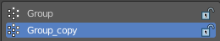
Add a copy of the active vertex group as a new group. The new group will be named like the original group with “_copy” appended at the end of its name. And it will contain associations to exactly the same vertices with the exact same weights as in the source vertex group.

Copy Vertex Group to Selected
Copy all vertex groups to other selected objects provided they have matching indices (typically this is true for copies of the mesh which are only deformed and not otherwise edited).

Mirror Vertex Group
Mirrors weights and/or flips group names from one side of a symmetrical mesh to the other.
Only mirroring along local X axis is supported. Vertices that have no corresponding vertex on the other side will not be affected. Note, the weights are not transferred to the corresponding opposite bone weight group.

Mirror Vertex Group (Topology)
Performs the Mirror Vertex Group with the Topology Mirror option enabled.

Remove from All Groups
Unassigns the selected vertices from all groups. Even locked.

Clear Active Group
Remove all assigned vertices from the active group. The group is made empty. Note that the vertices may still be assigned to other vertex groups of the object. This feature does not affect locked groups.

Delete All Unlocked Groups
Remove all vertex groups from the object that are not locked.

Delete All Groups
Remove all vertex groups from the object.

Lock All
Lock all groups.

Unlock All
Unlock all groups.

Lock Invert All
Invert group locks.


Move Vertex Group Up / Down
Moves the selected vertex group up or down in the list.

Assign
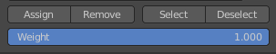
Assign the selected vertices to the active vertex group.

Remove
Remove the selected vertices from the active group.

Select
Select all vertices in the group.

Deselect
Deselect all vertices in the group.

Weight
The weight value that gets assigned to the selected vertices.

Auto Normalize
Make sure that all bone-deforming vertex groups adds up to 1.0 while weight painting or assigning to vertices.

Shape Keys panel

This panel allows you to see and manage shape keys. A shape key is a vertex animation.
Shape keys are for example used for facial animations, when you don't want to use a face rig with bones. The idea is to model a shape key pose for smiling, one for laughing, one for sad, and so on. And then blend the shape key poses together as needed.
Shape keys are also called morph targets or blend shapes.

Workflow

In Object mode add a shape key. This first shape key is called Basis by default. It is the base for the vertex animation. This basis shape key is the base shape for all further shape keys. It cannot be modified or keyframed.
Now add a second shape key. This second shape key will have more controls so that you can modify it in the needed way.


Enter edit mode with this key 1 selected.
Modify the geometry by moving some vertices around.
Switch back to Object mode.


Have a look at the value slider. This slider defines how the key 1 shape key blends with the Basis shape key.
Move it from value 0 to value 1. You will notice that the vertices that you have modified in Key 1 will now start to move to a new position. Dependent of how strong the value is. With a value of 1 it will be at the position of how you modeled it.

To keyframe this shape click at the Animate property dot behind the slider. The slider will change its color. And the dot will change to a rhombus shape to indicate that there is a keyframe recorded at this frame.
Or you right click at the slider, and choose Insert Keyframe in the menu.
Move to another frame. Change the slider value, and set another keyframe.

Recorded keyframes can be found and further tweaked in the Dope sheet Editor in Shape Key Editor mode. Here you can also record further keyframes under Key / Insert Keyframes. And control the slider values from the channel list.
Add more shape keys and model and animate them as you need them.


Active Shape Key Index
A List of the shape keys for this mesh.
It contains two types of shape keys. Basis is the base shape. The other type relies at this shape as the base.

Shape Key name
The name of the shape key. It can be renamed by double clicking at it.

Slider value
The blend value of this shape key. The Basis shape key does not have such a slider.

Lock
The lock icon at the end of a group name locks the group from being editable.

Drag Handler
The two vertical lines at the end is a handler with which you can expand the list.

Search Field
You can expand a search field at the bottom of the list. Type in your term and hit enter to filter for your term.

Invert
Exclude the search term instead of searching for it.

Sort by Name
Sort the List by name.

Add +
Create a shape key.

Remove -
Delete the selected shape key.

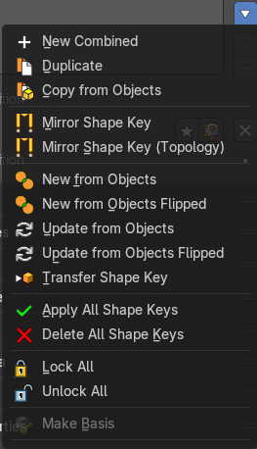
Specials Menu

New Combined
Add a new shape key with the current deformed shape of the object.

Duplicate
Makes a duplicate of the current selected shape key.

Copy from Objects
Copy the active shape key of another selected object to this one.

Mirror Shape Key
Mirror the shape keys on the X axis. This will not work if the mesh vertices is not fully symmetrical.

Mirror Shape Key (Topology)
Mirror the shape keys on the X axis. But detects the mirrored vertices based on the topology of the mesh. The mesh vertices do not have to be perfectly symmetrical for this action to work.

New from Objects
Add the vertex positions of selected objects as shape keys or update existing shape keys.

New from Objects Flipped
Add the vertex positions of selected objects as shape keys or update existing shape keys. But flipped.

Update from Objects
Add the vertex positions of selected objects as shape keys or update existing shape keys with matching names.

Update from Objects
Add the vertex positions of selected objects as shape keys or update existing shape keys with matching names. But flipped.

Transfer Shape Key
Copy the active shape key of another selected object to this one.

Apply all Shape Keys
Apply all shape keys to the mesh, also removes shape keys.

Delete all Shape Keys
Delete all shape keys at this mesh.

Lock All
Lock all shape keys of the active object. They cannot be edited anymore then.

Unlock All
Unlock all shape keys of the active object.

Make Basis
Make this shape key the new basis key, effectively applying it to the mesh. Note that this applies the shape key at its 100% value.

Move to Bottom
Move the shape key to the bottom of the list.

Move Shape Key Up / Down
Moves the selected shape key up or down in the list.

Relative
Set the shape keys to Relative or Absolute.


Relative
The shape is defined relative to the Basis or another specified shape key. And can be adjusted in its settings.

Shape Key Lock (pin icon)
Show the active shape in the 3D Viewport without blending. Shape Key Lock gets automatically enabled while the object is in Edit Mode.

Shape Key Edit Mode (edit mode icon)
If enabled, when entering Edit Mode the active shape key will not take maximum influence as is default. Instead, the current blend of shape keys will be visible and can be edited from that state.

Value
The weight of the blend between the shape key and its basis key. 0 means no influence, 1 full influence.

Range
Minimum and maximum range for the influence value of the active shape key.

Vertex Group
Limit the active shape key deformation to a vertex group.

Relative To
Select the shape key to deform from. It does not need to be the Basis shape key, but can also be another shape key.

Absolute

The shape changes over time, as defined in its settings.

Shape Key Lock (pin icon)
Show the active shape in the 3D Viewport without blending. Shape Key Lock gets automatically enabled while the object is in Edit Mode.

Shape Key Edit Mode (edit mode icon)
If enabled, when entering Edit Mode the active shape key will not take maximum influence as is default. Instead, the current blend of shape keys will be visible and can be edited from that state.

Re-Time Shape Keys (clock icon)
Absolute shape keys are timed, by order in the list, at a constant interval. This button resets the timing for the keys. Useful if keys were removed or re-ordered.


Interpolation
The interpolation method between shape keys.

Evaluation Time
Evaluate the shape key influence over the defined time. The evaluation starts at influence 0, and reaches 1 at the end of the value of this timer.

Custom Properties Panel


Here you can define custom properties that can be used for scripting.

Here you might also find custom properties from addons or scripts.

Add
Adds a new property.


Edit
Opens a panel where you can adjust the settings for the custom property.

Remove
Removes the property.

